Review Apparent Weight
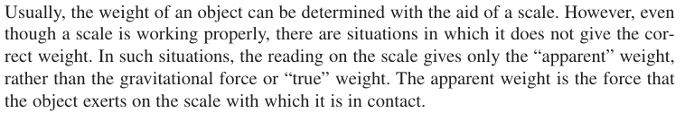

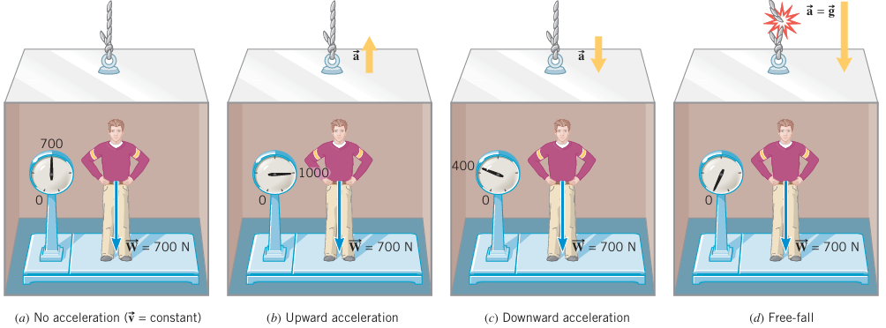

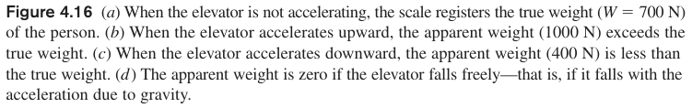
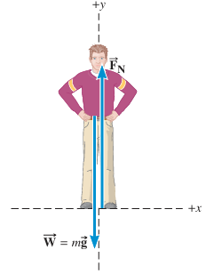
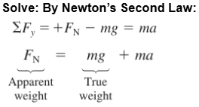

F=ma Problems with Colinear Forces (No Friction)
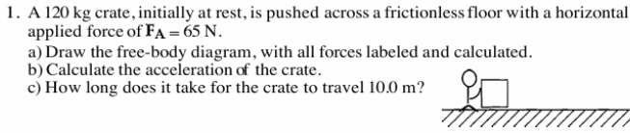

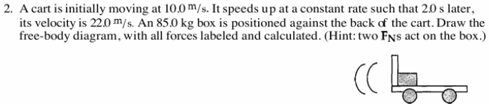

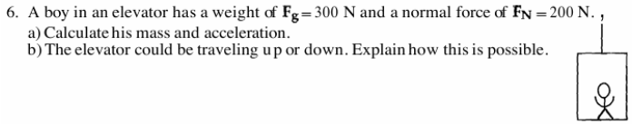

Daw FBD and Find the Net Force
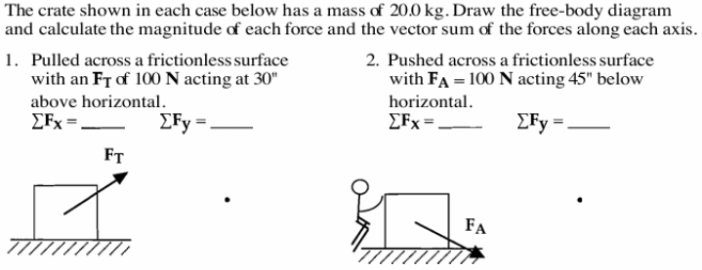

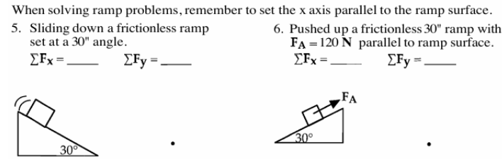

F=ma Problems with Non-Colinear Forces (No Friction)

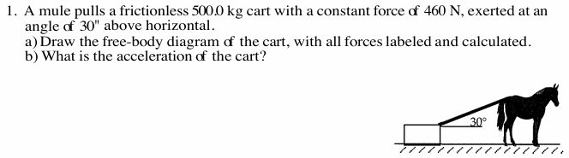

3. A worker pushes a 110.0 kg box, initially at rest, across a frictionless floor. She exerts a 400 N force on the box, at an angle of 45’’ below horizontal.
- Draw the free-body diagram of the box and calculate the acceleration of the box.
- How long does it take for the box to slide 5.0 meters?
